- Purpose
  - The purpose of this document is to describe the procedure for assembling the SoliChem puck cage.
- Scope
  - This SOP applies to all equipment assembly team members. The process applies to the following machine ID’s:
EP50340EQS0600BE1200 – SoliChem Puck Holder
- Responsibilities
  - The operations manager/supervisor is responsible for enforcing this SOP.
- Materials
  - The proper materials needed for this process are listed on the machine work order.
  - #44 Drill Bit
  - Chop Saw
  - Drill fixture
  - Rod Support Fixture
- Definitions

- Procedure
  - Use the saw fixture to cut the support rods (E29310) into 7.25” pieces. (These may be precut prior to build)
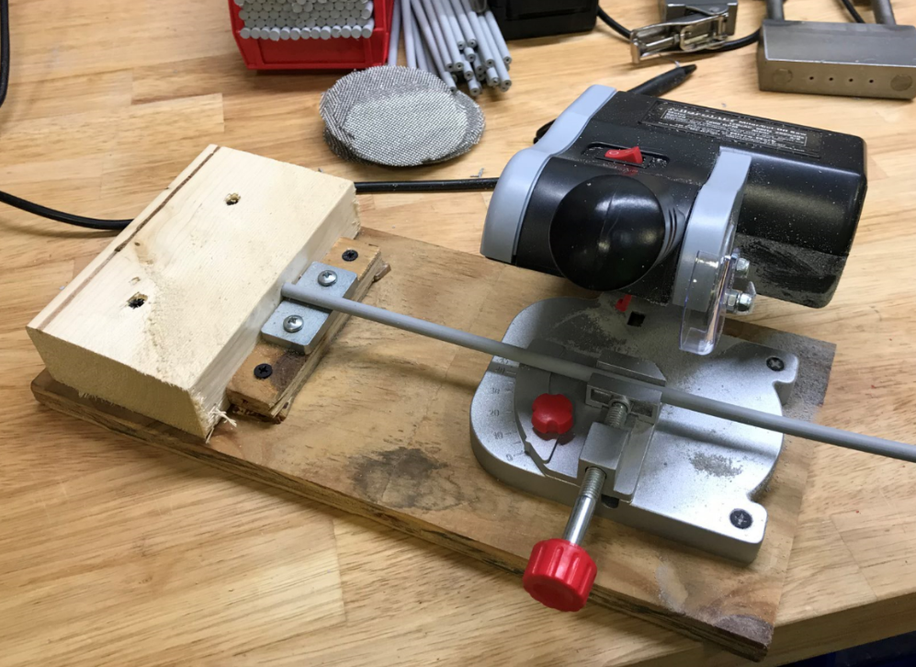
  - Use the drill fixture and a #44 drill bit as shown to drill a hole into each end of the rods. Ensure to drill in short depths while removing the bit to clear the chips. Leave the drill bit long to drill the hole deep enough. (Rods may be drilled prior to build)
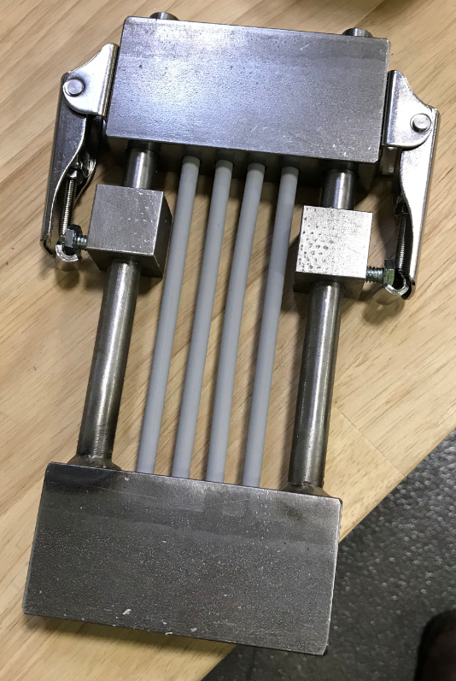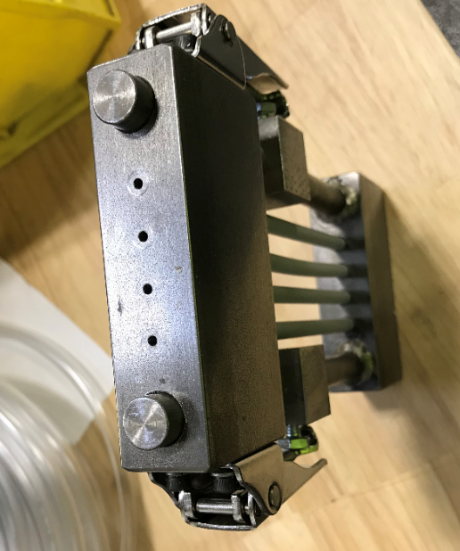
  - Take 4 of the rods and clamp them into the support fixture as shown. Make sure the rods are as level as possible to avoid twisting.
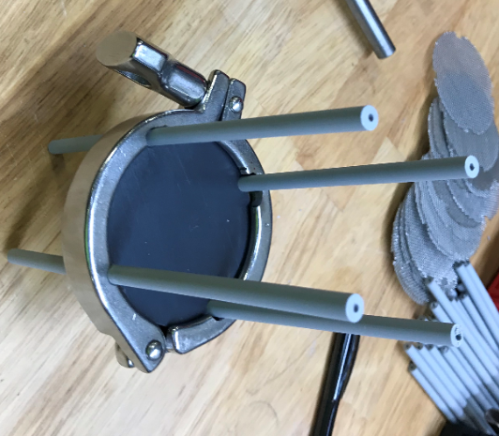
  - Take a screen disk (E29309) and use a puck cage flange (E29308) to mark out the hole locations. Use the trimming tool to trim the screen. About 2 “bites” deep is sufficient.
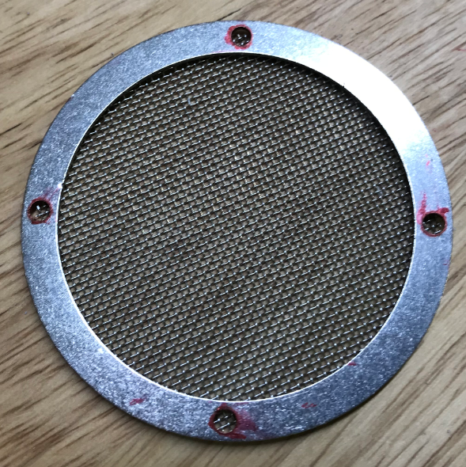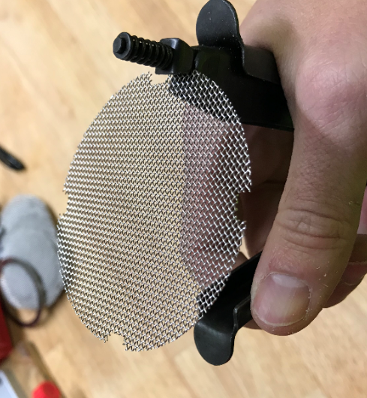

  - Sandwich the screen between 2 cage flanges (E29308) and use 4 torx head screws (E29311) to attach it to the four rods as shown. Ensure the screws are tight and the flanges don’t move.
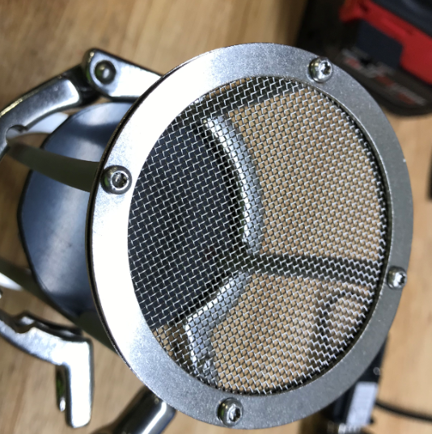
  - Then use 4 more torx head screws (E29311) to attach the upper flange (E28757) to the other end of the rods. Ensure the screws are tight and the flange doesn’t move.
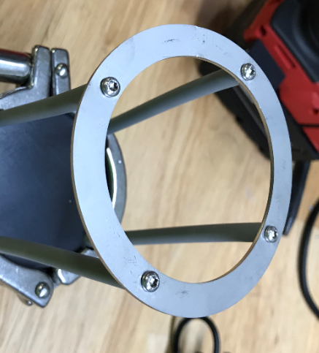
  - Remove the cage assembly from the fixture. You may need to twist the assembly to get it to the correct orientation.
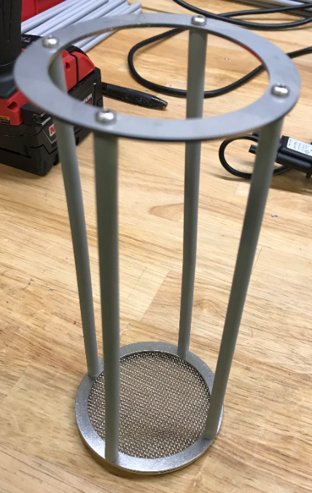
- References (optional section as needed)

- Training Guide

Functional Training Groups Requiring Training
Equipment Assembly Group

- SOP Change Control

Date of Change | Reason for Change
TBD | This is the first version of the S.O.P. hence there are no revisions to this document.
8/11/2021 | Added QC Checkpoint
11/7/2023 | Updated rods maybe cut and drilled ahead of build
3/31/2025 | Combined MSAS and G20 instructions together

Approvals

Submitter/Author Approval:__________________________________ Date:______________________

Management Approval:______________________________________ Date:______________________

QAU Approval:_____________________________________________ Date:______________________

